LAB REPORT # 07



Submitted by:

Submitted by:

Name | Registration No.
Muhammad Abdullah | FA24-BSE-042

Submitted to: Raheel Ahmed
Course: Fundamentals of Digital Logic Design(EEE240)
Dated: MAR 29, 2026.

DEPARTMENT OF COMPUTER SCIENCE
COMSATS UNIVERSITY ISLAMABAD,ISLAMABAD CAMPUS

4-Bit Adder :

Circuit:
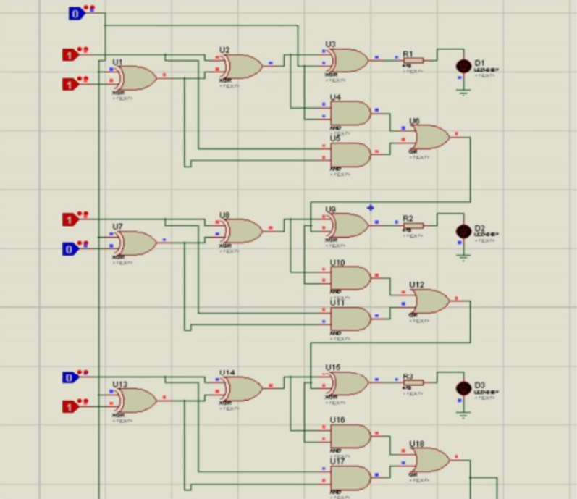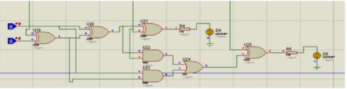

Truth Table:

A | B | Cin | Sum (S) | Carry (Cout)
0 | 0 | 0 | 0 | 0
0 | 0 | 1 | 1 | 0
0 | 1 | 0 | 1 | 0
0 | 1 | 1 | 0 | 1
1 | 0 | 0 | 1 | 0
1 | 0 | 1 | 0 | 1
1 | 1 | 0 | 0 | 1
1 | 1 | 1 | 1 | 1

4-Bit Subtractor :
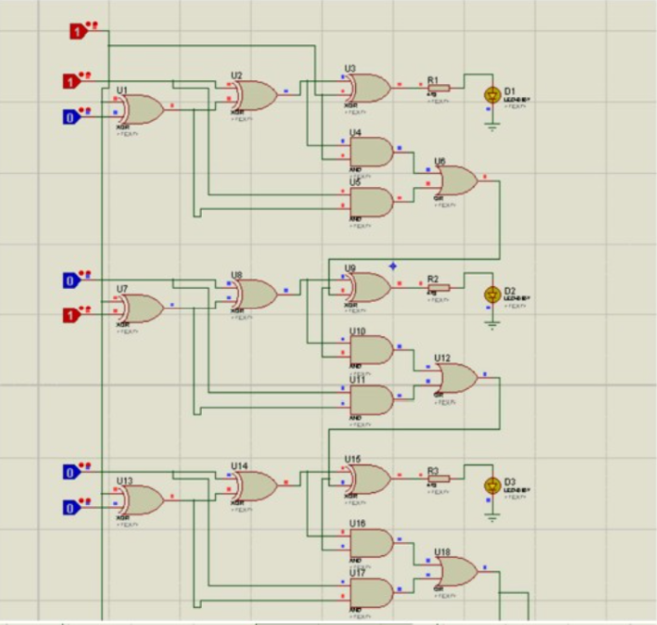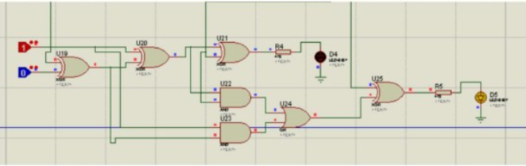

Truth table:
A | B | B' (B⊕1) | Cin | Difference (D) | Cout | Borrow
0 | 0 | 1 | 1 | 0 | 1 | 0
0 | 1 | 0 | 1 | 1 | 0 | 1
1 | 0 | 1 | 1 | 1 | 1 | 0
1 | 1 | 0 | 1 | 0 | 1 | 0

Conclusion
In this lab, we learned how binary addition and subtraction can be implemented using digital logic circuits. We first studied the operation of a 1-bit full adder, which forms the foundation for building multi-bit arithmetic circuits. By cascading four full adders, we designed a 4-bit ripple-carry adder capable of performing binary addition.
We also learned how the same adder circuit can perform subtraction through the 2’s complement method, where the subtrahend (B) is inverted and a logic 1 is added as Cin. This allowed us to perform A – B using the same hardware used for addition. The lab demonstrated the role of logic gates such as XOR, AND, and OR in generating sum and carry/borrow bits.
Overall, this experiment helped us understand:
- The internal working of a full adder
- Cascading full adders to build multi-bit arithmetic units
- How subtraction is achieved using 2’s complement
- The practical importance of ripple-carry propagation
- Implementing and verifying results using simulation

